Shift Registers in Digital Logic

Flip flops can be used to store a single bit of binary data (1or 0). However, in order to store multiple bits of data, we need multiple flip flops. N flip flops are to be connected in an order to store n bits of data. A **Register** is a device which is used to store such information. It is a group of flip flops connected in series used to store multiple bits of data.

The information stored within these registers can be transferred with the help of **shift registers**. Shift Register is a group of flip flops used to store multiple bits of data. The bits stored in such registers can be made to move within the registers and in/out of the registers by applying clock pulses. An n-bit shift register can be formed by connecting n flip-flops where each flip flop stores a single bit of data.  
The registers which will shift the bits to left are called “Shift left registers”.  
The registers which will shift the bits to right are called “Shift right registers”.

Shift registers are basically of 4 types. These are:

1. Serial In Serial Out shift register
2. Serial In parallel Out shift register
3. Parallel In Serial Out shift register
4. Parallel In parallel Out shift register

**Serial-In Serial-Out Shift Register (SISO) –**

The shift register, which allows serial input (one bit after the other through a single data line) and produces a serial output is known as Serial-In Serial-Out shift register. Since there is only one output, the data leaves the shift register one bit at a time in a serial pattern, thus the name Serial-In Serial-Out Shift Register.

The logic circuit given below shows a serial-in serial-out shift register. The circuit consists of four D flip-flops which are connected in a serial manner. All these flip-flops are synchronous with each other since the same clock signal is applied to each flip flop. Eg:data input 1010

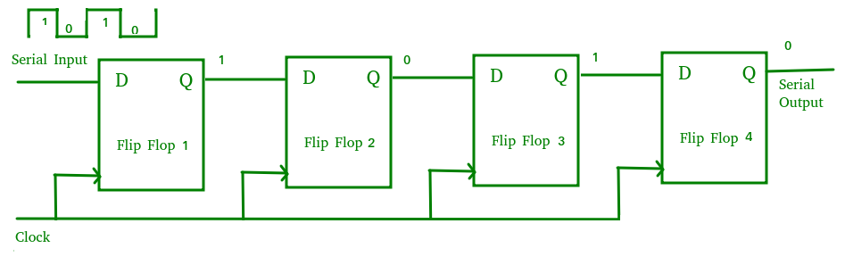

The above circuit is an example of shift right register, taking the serial data input from the left side of the flip flop. The main use of a SISO is to act as a delay element.

After 4th clock pulse entire data taken into the registers and after 7th clock pulse entire data taken out the registers.

### Example

### SISO

Let us see the working of 3-bit SISO shift register by sending the binary information **“011”** from LSB to MSB serially at the input.

Assume, initial status of the D flip-flops from leftmost to rightmost is Q2Q1Q0=000. We can understand the **working of 3-bit SISO shift register** from the following table.

|  |  |  |  |  |
| --- | --- | --- | --- | --- |
| **No of positive edge of Clock** | **Serial Input** | **Q2** | **Q1** | **Q0** |
| 0 | - | 0 | 0 | 0 |
| 1 | 1 LSB | 1 | 0 | 0 |
| 2 | 1 | 1 | 1 | 0 |
| 3 | 0 MSB | 0 | 1 | 1LSBLSB |
| 4 | - | - | 0 | 1 |
| 5 | - | - | - | 0MSBMSB |

The initial status of the D flip-flops in the absence of clock signal is Q2Q1Q0=000Q2Q1Q0=000. Here, the serial output is coming from Q0Q0. So, the LSB 11 is received at 3rd positive edge of clock and the MSB 00 is received at 5th positive edge of clock.

Therefore, the 3-bit SISO shift register requires five clock pulses in order to produce the valid output. Similarly, the **N-bit SISO shift register** requires **2N-1** clock pulses in order to shift ‘N’ bit information.

### Serial-In Parallel-Out shift Register (SIPO) –

The shift register, which allows serial input (one bit after the other through a single data line) and produces a parallel output is known as Serial-In Parallel-Out shift register.

The logic circuit given below shows a serial-in-parallel-out shift register. The circuit consists of four D flip-flops which are connected. The clear (CLR) signal is connected in addition to the clock signal to all the 4 flip flops in order to RESET them. The output of the first flip flop is connected to the input of the next flip flop and so on. All these flip-flops are synchronous with each other since the same clock signal is applied to each flip flop. Eg:1010

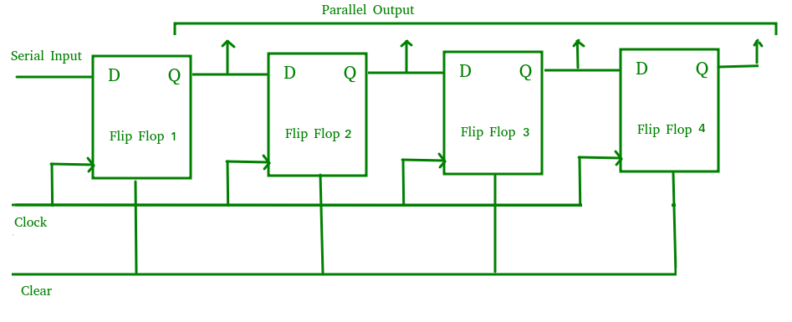

The above circuit is an example of shift right register, taking the serial data input from the left side of the flip flop and producing a parallel output. They are used in communication lines where demultiplexing of a data line into several parallel lines is required because the main use of the SIPO register is to convert serial data into parallel data.

After 4th clock pulse entire data taken out from registers.

**On 4th clock pulse itself entire data taken out.**

### Parallel-In Serial-Out Shift Register (PISO) –

The shift register, which allows parallel input (data is given separately to each flip flop and in a simultaneous manner) and produces a serial output is known as Parallel-In Serial-Out shift register.

The logic circuit given below shows a parallel-in-serial-out shift register. The circuit consists of four D flip-flops which are connected. The clock input is directly connected to all the flip flops but the input data is connected individually to each flip flop through a multiplexer at the input of every flip flop. The output of the previous flip flop and parallel data input are connected to the input of the MUX and the output of MUX is connected to the next flip flop. All these flip-flops are synchronous with each other since the same clock signal is applied to each flip flop. Eg data ->1010

shift/ $load$

A B C D

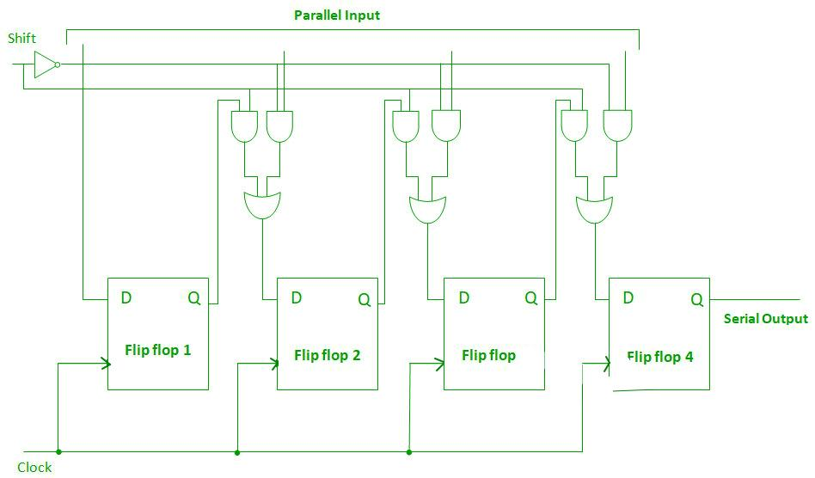

Ist clock pulse all the data loaded. Output of f/f 4 should be 0

Load operation completed . next shift operation.

2nd clock pulse shift line enabled , one right shift carried out and now Q4 should be 1.

3rd clock pulse again right shift then Q4 become 0.

4th clock pulse again right shift then Q4 become 1. Now all the data takenout.

A Parallel in Serial out (PISO) shift register us used to convert parallel data to serial data.

When shift/ $load$ is low alowing each data bit to be applied to the D input of its each flip-flop.

When shift/load is high shift operation is carried out.

**On first clock pulse the data simultaneously entered and 2nd 3rd and 4th clock pulse the complete data taken out.**

### Parallel-In Parallel-Out Shift Register (PIPO) –

The shift register, which allows parallel input (data is given separately to each flip flop and in a simultaneous manner) and also produces a parallel output is known as Parallel-In parallel-Out shift register.

The logic circuit given below shows a parallel-in-parallel-out shift register. The circuit consists of four D flip-flops which are connected. The clear (CLR) signal and clock signals are connected to all the 4 flip flops. In this type of register, there are no interconnections between the individual flip-flops since no serial shifting of the data is required. Data is given as input separately for each flip flop and in the same way, output also collected individually from each flip flop.

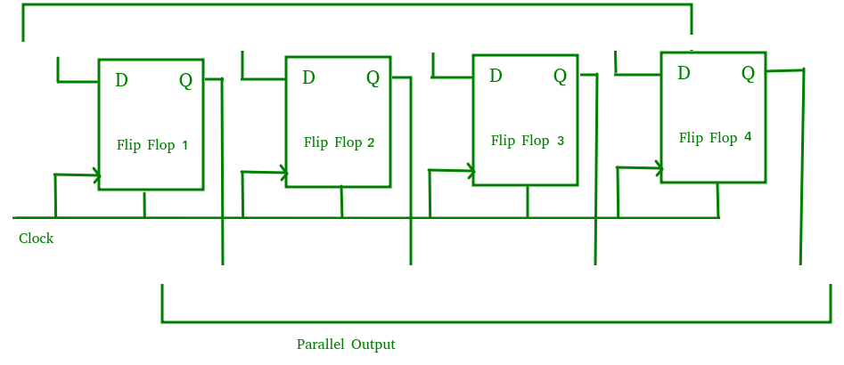

A Parallel in Parallel out (PIPO) shift register is used as a temporary storage device and like SISO Shift register it acts as a delay element.